Save the assignment file and name it with your name as suffix, like M1_assignment_JohnSmith.docx. Include any code under the questions where appropriate. Show the results and clearly answer the questions. Submit the .docx file as the first file for this assignment.

Make sure to get rid of the pictures below, since they existed to show you where to find the folders. Once done, they are no longer needed.

1. (15 pts) Get familiar with accessing SAS Studio via SAS OnDemand.

* In the ‘Files (Home)’ directory, create a subfolder and name it ‘STAT674’. This will be the folder where you will save all your course data and code files. You can do this by hover over the directory and right click on your mouse -> New -> Folder.

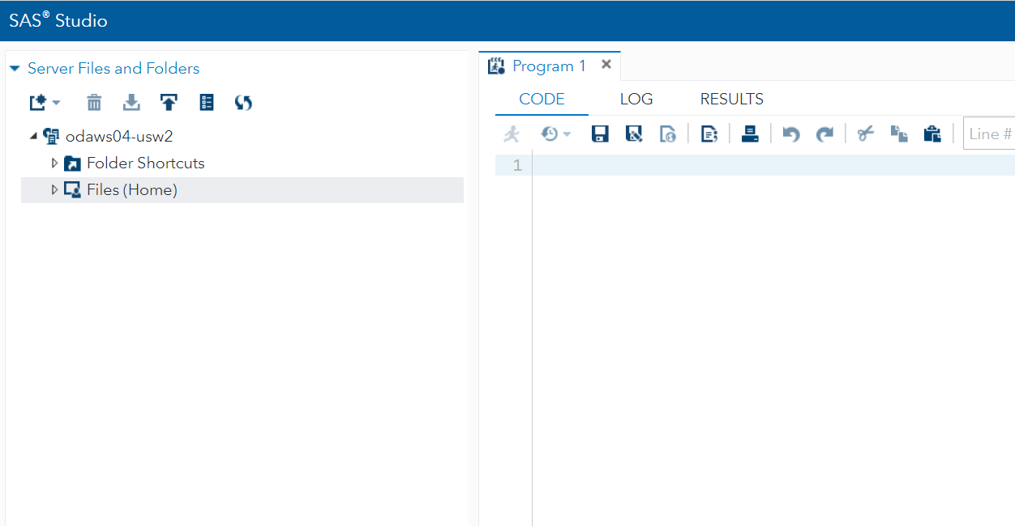

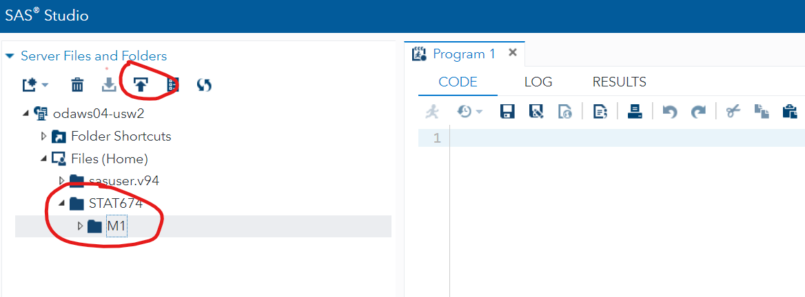

* Under STAT674, create another subfolder called ‘M1’. Download the dataset *M1_data.dat* to your computer and then upload to this M1 folder.
  1. Right click on the folder M1 -> Properties. What’s the location/path for this folder? Take a screenshot of the Properties window and paste below, and type your answer as well.
  2. Similarly, find out the location of the dataset *M1_data.dat*.

1. Questions 2-5 is in the sas file *m1_assignment_Q2345.sas*.

Download this code file from Canvas to your local drive and then upload to your M1 folder in SAS Studio. Click the file to open and follow the code and questions carefully. Put your answers under each question in the comment section.

After you are done with all the 4 questions, save your code file. Also, use the Print Code button to print to a PDF file and submit as a second file to this assignment. Refer to the picture below for the Print Code button. Name the file properly, such as M1_assignment_code_JohnSmith.pdf.

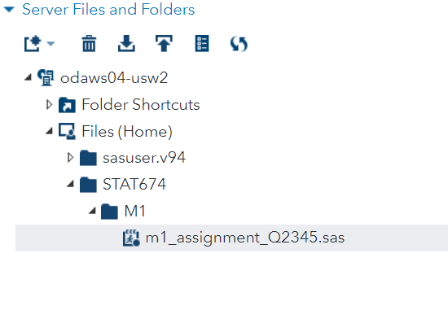

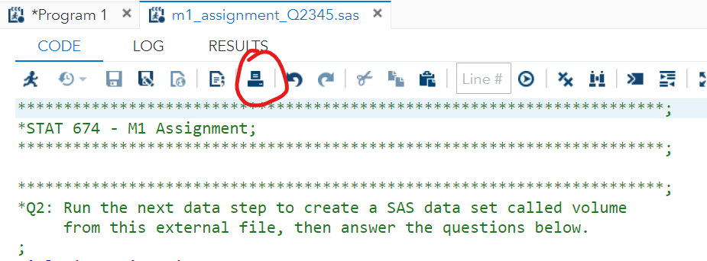

1. (15 pts) Use the following libname statement to access the folder ‘M1’ you just created

* To do so, you just need to replace the red text below with the folder path you got for part 1.1, and run this code in SAS.

libname M1 “put your folder path here”;

* Go to the libraries tab on the left panel, and click on the little triangle to the left of the word ‘Libraries’ to expand it. Refer to the picture above to locate the libraries. It’s in the far left bottom corner.

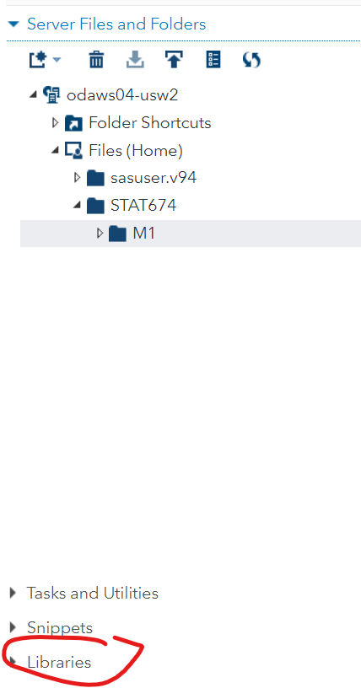

* 1. What’s in *Libraries* tab? You can take a screenshot to better illustrate.
  2. Most of the libraries here are ‘public’ libraries provided by SAS. Locate your personal library *M1*. Click on the left triangle to expand the library view. What’s in it? Do you see the raw data file *M1_data.dat*? Why or why not?
  3. Now run the code below. What’s in the M1 library now?

**Data** m1.test;

X=**1**;

**Run**;